Community Events and Participation Database

Problem Definition and Purpose
Hosting events is just one element of an organization's work. Member lists, event sign-ups, and check-ins can end up in multiple spreadsheets or files. Getting the data is one thing; understanding what it means and how it can be used to support the communities in which the organizations work is another. The Community Events and Participation Database (CEPD) stores records in several related tables, allowing organization administrators to track events, registrations, and attendance in one place and view participation across communities.
RSVPs are used to plan resources and capacity prior to an event. After the event, you can use the same data to see whether attendance was as expected or whether some people simply never RSVPed. The same data can be used to provide different views on the community.
How could an organizer use this information?
1. How often do the events get hosted, across all the organizations?
2. Do the users who have RSVP'd to an event have a check-in recorded?
3. Low RSVP follow-through rates are either limited to certain events or a regular occurrence, and where?
4. How many people check in to events without having submitted an RSVP?
These questions can provide insight into what might be going on in their community. The numbers on their own, though, won't tell you why something is happening or whether the organization is achieving its objectives.

Relational Database Design
Users have one global account via platform_user. The organization stores the communities and the organisation_membership records that the users are members of. The organization can have smaller groups within it via organisation_group; group_membership is the record that links the organization to those groups. The organization can host events directly or through one of its groups; RSVPs and attendance are stored separately in the event_rsvp and event_attendance tables, respectively. Figure 2 in the appendix shows how the records are connected in the database.
Users can be members of multiple organizations or groups via the membership tables without having to duplicate their global account. The primary key identifies the individual record, and the foreign key ensures that a membership or RSVP can't reference a non-existent record. Composite foreign keys also ensure that an RSVP is only ever for a member of the same organization as the event.
Events have a lifecycle: you can have interest shown via an RSVP, interest shown without an RSVP, and attendance without an RSVP. Those are all different scenarios and need to be handled differently. RSVPs and attendance are in separate tables, but both link to the event and the organization. That way you maintain the distinction between what someone intended to do and what happened at the event.

Database Implementation and Synthetic Data
A Python generator was used to create synthetic records for the five fictional communities (users, orgs, memberships, groups, events, RSVPs, and attendance). The records were saved as 8 TSV files (one per table) and then imported into MySQL via sql/seed.sql. The import order is in accordance with the foreign key constraints as defined in sql/schema.sql. Individual fields are documented in docs/data-dictionary.md.
The dataset contains 143,014 records in total (28,080 platform users, 30,000 organization memberships, and 378 events). All records were imported with no skipped rows or warnings. Foreign key checks were enabled, and the MySQL session was set to UTC to preserve the generated timestamps. Validation checks found no invalid event times, orphaned RSVPs or attendance records, and no cases of group-only participation without a matching group membership. Eight queries were used to analyze event activity and participation. The queries and their results can be found in sql/queries/ and sql/results/, respectively.

SQL Analysis and Findings
Over the period in question, the 5 communities hosted 209 events (ranging from 18 to 22 per month). Gaming hosted the most events, with 60. These numbers were derived by filtering and grouping events by date, then joining them to the organization to allow comparison across the communities.
Gaming also had 5,112 RSVPs. Only 44.9% of those had a recorded check-in for the same member and event. The other four organizations ranged from 76.5% to 83.2%. That raised another question. Was it just a few events performing poorly, or was it a problem across the whole organization? A CTE (Common Table Expression) was used to calculate follow-through at the event level, with a HAVING clause to filter to events with at least 20 attending RSVPs. Of the 51 Gaming events that met that criterion, 31 had a follow-through below 50%. None of the 106 qualifying events from the other communities had a follow-through below 50%.
There were also several people who had checked in but had never actually submitted an RSVP. A NOT EXISTS subquery identified 958 of these from the 9,474 total, so that's 10.1% of the attendance. Gaming had the highest proportion at 14.0%, compared with 7.3%- 9.1% across the other categories.

Visualization and Interpretation
Looking at tables of results can make it difficult to see patterns, and a chart based solely on bar size can be very misleading. Event activity, RSVP follow-through, and walk-in attendance are all shown side by side, with each organization in the same order. The percentages consider the differing numbers of registrations and check-ins across the organizations. The actual values are also printed alongside each bar so the reader can see the exact figures rather than having to work them out from the chart.
In that view, Gaming was by far the busiest, with 60 events, had the lowest percentage of RSVPs that checked in (44.9%), and the highest proportion of walk-ins (14.0%). An organizer could see all of that without having to go through a whole bunch of tables of results. It would still be up to them to determine whether that reflected attendance.
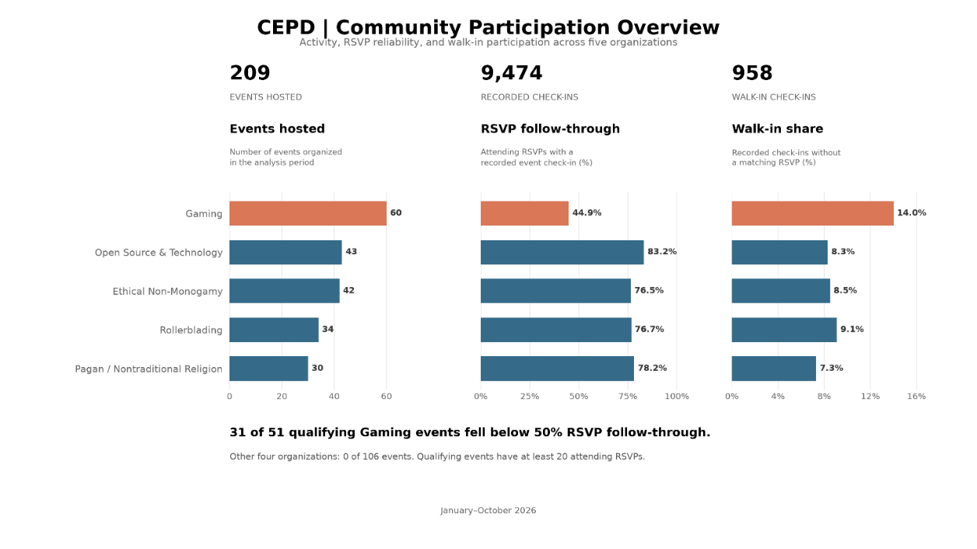
Figure 1 Community Participation Overview: Event activity, RSVP follow-through, and walk-in participation (Jan-Oct 2026).
Conclusions, Limitations, and Reflection
Synthetic data for five fictitious communities show what the database can analyze, but they don't tell us how people would use it in an organization. For the analysis to be useful, the organizers would need to record registrations and attendance accurately and consistently. If someone shows up to an event but isn't checked in, the analysis could show low RSVP follow-through, even though they were there. Missing data could alter the patterns the organizers see and lead them to focus on problems that may not actually exist.
The questions that the organizers want to answer should come first and inform the database design. The way memberships, RSVPs, and attendance were structured was a direct result of the questions being asked. The reality is that we don't know whether it will be usable and maintainable in practice. If it's just going to create more work than it saves, then it's of very little benefit. The system should enable the organizers to see the changes worth looking at, talk to their members about what's going on, and make a judgment about what is, in fact, appropriate for their communities.

Appendix A — Entity-Relationship Diagram
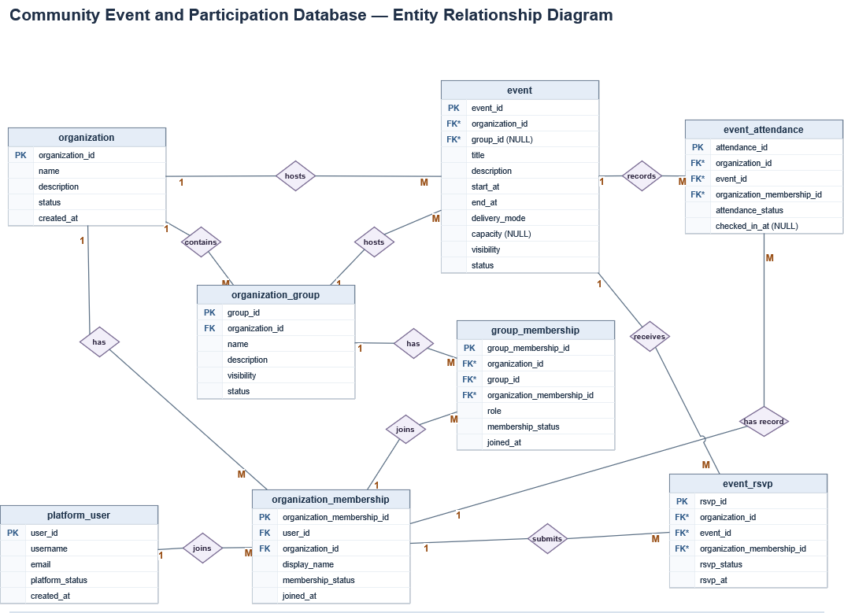
Figure 2 Entity Relationship Diagram of the Community Events and Participation Database (CEPD)

